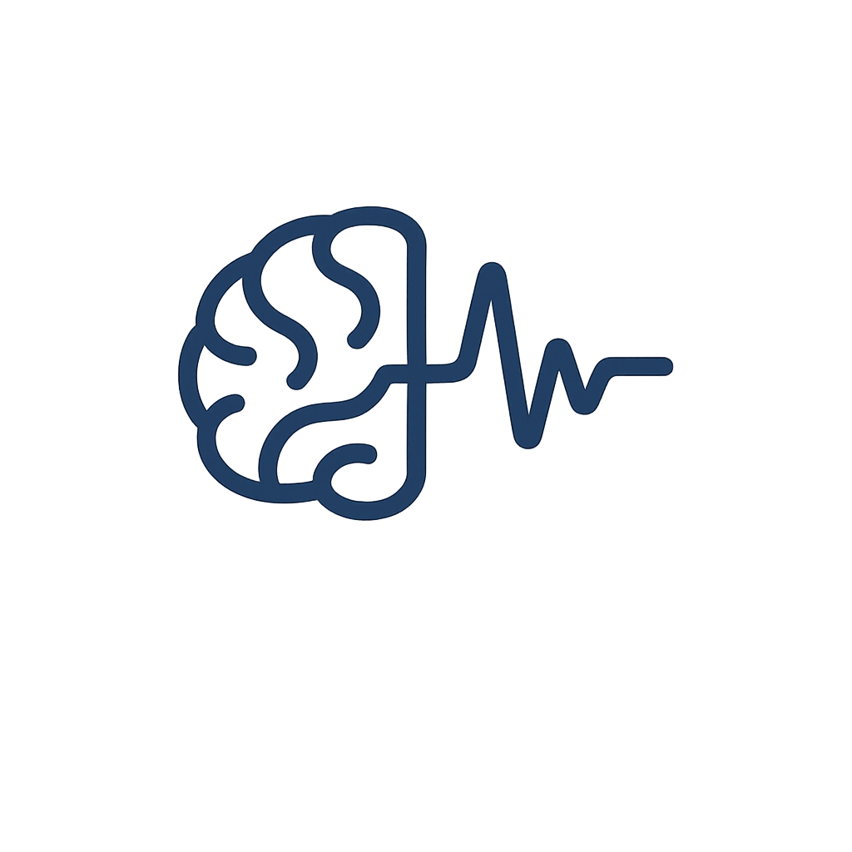
EEG-Based Parkinson’s Disease Diagnosis
Applied AI Students – A25
University of Bradford

Date: 28th of October, 2026
Version: 2.0

Summary
This project aims to develop an AI-assisted diagnostic support system to help clinicians diagnose Parkinson’s Disease (PD) with greater confidence. Using EEG (electroencephalogram) signals and deep learning models such as EEGNet, the system will identify neural activity patterns commonly linked to PD. The tool will provide clinicians with an objective, data-driven insight to complement clinical judgement and enhance diagnostic reliability.

Business Case / Benefits
- Parkinson’s Disease (PD) affects over 10 million people worldwide (Parkinson’s Foundation, 2023). Diagnosis still depends mainly on clinical observation, which can be subjective.
- EEG studies show key brainwave changes in Parkinson’s Disease, including altered theta, alpha, and beta synchrony (Karimi et al., 2022), effective EEG-based PD classification using machine learning (Aljalal et al., 2022), and alpha/beta power variations as reliable biomarkers (Huang et al., 2024).
- This project builds on these findings to develop a deep learning–based diagnostic support tool that provides objective EEG insights, helping clinicians diagnose PD with greater confidence and consistency.

Team
Justyna Dobersztajn – Project Manager, ML Engineer
Aleeza Azad – AI Engineer, Graphic Designer
Diba Dabiransari – Data scientist, AI Ethics Specialist

Clinical Collaborator – NHS Research Partners (To be confirmed.)
Research Supervisors – Dr. Ali Elmahmudi, Dr. Kulvinder Panesar

Project Goal (SMART)
- Develop and validate an EEG-based system designed to assist clinicians in diagnosing Parkinson’s Disease.
- Achieve at least 85% classification accuracy and 80% sensitivity, consistent with benchmarks from previous research (Ruffini et al., 2019; Acharya et al., 2021).
- Use the “EEG: 3-Stim Auditory Oddball and Rest in Parkinson’s” dataset, analysing both resting-state and task-based brain activity.
- Ensure model interpretability and clinical relevance through collaboration with neurological experts.
- Deliver a validated prototype ready for evaluation by May 2026.

Project Scope
In-Scope:
- EEG data preprocessing and feature extraction
- Deep learning model development (EEGNet, CNN, LSTM)
- Development of a prototype diagnostic support interface
- Validation in collaboration with clinical experts

Out-of-Scope:
- Clinical trials or real patient testing
- Regulatory certification (e.g., FDA or CE marking)
- Development of new EEG hardware or sensors

Key Deliverables
- A cleaned and annotated EEG dataset for Parkinson’s diagnosis.
- A machine learning / deep learning model trained and validated on the dataset.
- An operational diagnostic interface for clinical use.
- A technical report and documentation outlining methods, performance, and clinical validation results.

Ethical & Legal Framework
GDPR Compliance:
All EEG data will be anonymised and sourced from public datasets approved for research use. No identifiable personal data will be processed.

AI Regulations:
The project complies with the EU Artificial Intelligence Act (2024) and the UK Data Protection and Digital Information Bill (2023), ensuring transparency, accountability, and human oversight.

Ethical Standards:
The tool is intended to support clinicians, not replace their judgement. Outputs will include confidence indicators, and bias checks and explainability tools will be used to promote fairness. The system will undergo ethical review before release.

Success Criteria
- ≥85% model accuracy and ≥80% sensitivity (validated on test data).
- Clinicians report improved diagnostic confidence through model insights.
- Full compliance with GDPR, EU AI Act, and institutional ethics.
- Functional, documented prototype ready by May 2026.

Budget Overview
Category | Details | Estimated Cost (£)
Labour | - 3 AI Engineers  - 25 hrs/week  - 24 weeks  - £26/hr (Salary.com, 2025) | 46,800
Computing Resources | - Google Colab Pro+  - Cloud Storage | 400 – 600
AI Tools | - ChatGPT Plus  - GitHub Copilot | 300 – 500
Project Management  &  Presentation | - Jira  - Trello  - GitHub  - Canva Pro  - PowerPoint | 100 – 200
Clinical Equipment | - EEG caps (32-channel)  - Electrodes  - Gels | 1,500 – 2,000  (MinTechStore.com, 2025)
Unexpected | - | 1,000
Total: £ 48k to 51k

Project Timeline
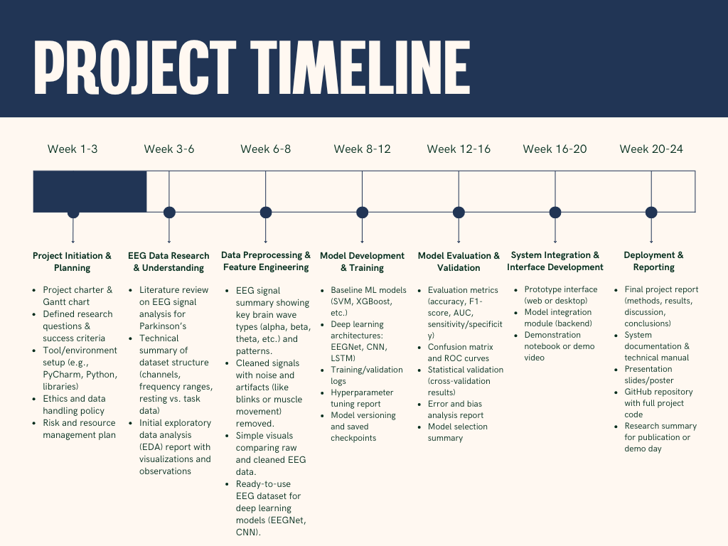

Strengths & Risks
Strengths
- Technical expertise: The team of three AI engineers specialises in EEG signal processing, deep learning, and model optimisation, aligning with current standards in biomedical AI (Acharya et al., 2021).
- Robust dataset: The EEG: 3-Stim Auditory Oddball and Rest in Parkinson’s dataset provides well-structured resting and task-state EEG signals, suitable for supervised learning (PhysioNet, 2024).
- Ethical compliance: The project fully complies with GDPR, the EU Artificial Intelligence Act (2024), and the UK Data Protection and Digital Information Bill (2023).

Risks
- Data variability: Limited diversity in EEG datasets may impact model generalisation (Karimi et al., 2022).
- Overfitting: High model complexity requires regularisation and extensive cross-validation (Goodfellow et al., 2016).
- Ethical exposure: Mismanagement of data or bias in training could breach compliance.
- Resource limitations: Restricted GPU capacity may affect model training and optimisation times.

